

Jackson, Tennessee
Epiphany
January 26, 2025

ORDER FOR THE WORSHIP OF GOD
January 26, 2025
PREPARATION FOR WORSHIP
PRELUDE
ANNOUNCEMENTS
SCRIPTURE MEDITATION: Matthew 11:28-30
Come to me, all who labor and are heavy laden, and I will give you rest. Take my yoke upon you, and learn from me, for I am gentle and lowly in heart, and you will find rest for your souls. For my yoke is easy, and my burden is light.
SILENT PRAYER
GOD CALLS US INTO HIS PRESENCE
† SALUTATION
In the name of the Father, and of the Son, and of the Holy Spirit.
Amen.
The Lord be with you! Ruth 2:4
And, also, with you!
Our help is in the name of the Lord. Psalm 124:8

† CALL TO WORSHIP: Psalm 103:19-22
The LORD has established his throne in the heavens, and his kingdom rules over all. Bless the LORD, O you his angels, you mighty ones who do his word, obeying the voice of his word! Bless the LORD, all his hosts, his ministers, who do his will! Bless the LORD, all his works, in all places of his dominion. Bless the LORD, O my soul!
†* PSALM 104, NO. 2: “O Worship the King”

† PRAYER OF ADORATION

† Congregation stands, if able | * Seating for latecomers at this time | All Scripture readings are from the ESV® Bible (The Holy Bible, English Standard Version®). ESV® Text Edition: 2016. Copyright © 2001 by Crossway, a publishing ministry of Good News Publishers. Assistive listening devices are available for use during worship services. Please inquire at the sound booth.
GOD CLEANSES US OF OUR SINS

CALL TO CONFESSION: Psalm 103:8-14
The Lord is merciful and gracious,
slow to anger and abounding in steadfast love.
He will not always chide,
nor will he keep his anger forever.
He does not deal with us according to our sins,
nor repay us according to our iniquities.
As a father shows compassion to his children,
so the LORD shows compassion to those who fear him.
For he knows our frame;
he remembers that we are dust.
CORPORATE CONFESSION (congregation kneels as able)
Eternal God, in whom we live and move and have our being, whose face is hidden from us by our sins, and whose mercy we forget in the blindness of our hearts: cleanse us from all our offenses, and deliver us from proud thoughts and vain desires, that with reverent and humble hearts we may draw near to you, confessing our faults, confiding in your grace, and finding in you our refuge and strength; through Jesus Christ your Son.
[Silent prayer of personal confession] Amen.

† ASSURANCE OF PARDON: Psalm 103:11-12
For as high as the heavens are above the earth, so great is his steadfast love toward those who fear him; as far as the east is from the west, so far does he remove our transgressions from us.
† GLORIA PATRI (with hands lifted)
Glory be to the Father, and to the Son,
And to the Holy Ghost;
As it was in the beginning,
Is now, and ever shall be,
World without end. Amen.
†* HYMN OF PRAISE, NO. 261: “What Wondrous Love Is This”
GOD CONSECRATES US BY HIS WORD
OLD TESTAMENT READING: Isaiah 43:1-7
This is the Word of the Lord
Thanks be to God!
EPISTLE READING: Ephesians 2:1-10
This is the Word of the Lord
Thanks be to God!
GOSPEL READING: John 1:1-17
This is the Gospel of Jesus Christ
Praise be to you, O Christ!
† HYMN OF PRAISE, NO. 253: “There Is a Fountain Filled with Blood”
READING OF GOD’S WORD: 2 Corinthians 1:1-11
PRAYER FOR ILLUMINATION
PREACHING OF GOD’S WORD
The Grace and Comfort of God
† CONFESSION OF FAITH: Apostles’ Creed
I believe in God the Father Almighty,
Maker of heaven and earth.
I believe in Jesus Christ, his only Son, our Lord,
who was conceived by the Holy Spirit,
and born of the virgin Mary.
He suffered under Pontius Pilate,
was crucified, died, and was buried;
he descended into hell.
The third day he rose again from the dead.
He ascended into heaven
and is seated at the right hand of God the Father Almighty.
From there he will come to judge the living and the dead.

I believe in the Holy Spirit,
the holy catholic* church,
the communion of saints,
the forgiveness of sins,
the resurrection of the body,
and the life everlasting. Amen. *catholic=universal
† PRAYER OF INTERCESSION AND LORD’S PRAYER
Our Father, Who art in heaven, Hallowed be Thy name.
Thy kingdom come. Thy will be done on earth as it is in heaven.
Give us this day our daily bread. And forgive us our debts,
As we forgive our debtors. And lead us not into temptation,
But deliver us from evil: For Thine is the Kingdom,
And the power, and the glory forever. Amen.
OFFERTORY
† DOXOLOGY (with hands lifted)
Praise God from whom all blessings flow;
Praise Him all creatures here below;
Praise Him above, ye heavenly host;
Praise Father, Son, and Holy Ghost. Amen
† PRAYER OF THANKSGIVING

GOD COMMUNES WITH US AT HIS TABLE
† SURSUM CORDA
Lift up your hearts.
We lift them up to the Lord.
Let us give thanks to the Lord our God.
It is right to give our thanks and praise.
It is right, and good, and a joyful thing, that we should at all times and in all places give thanks to You, holy Lord, almighty Father, everlasting God, through Jesus Christ our Lord. Therefore with angels and arch angels and with all the company of heaven we praise and magnify Your glorious name, evermore praising you and singing …
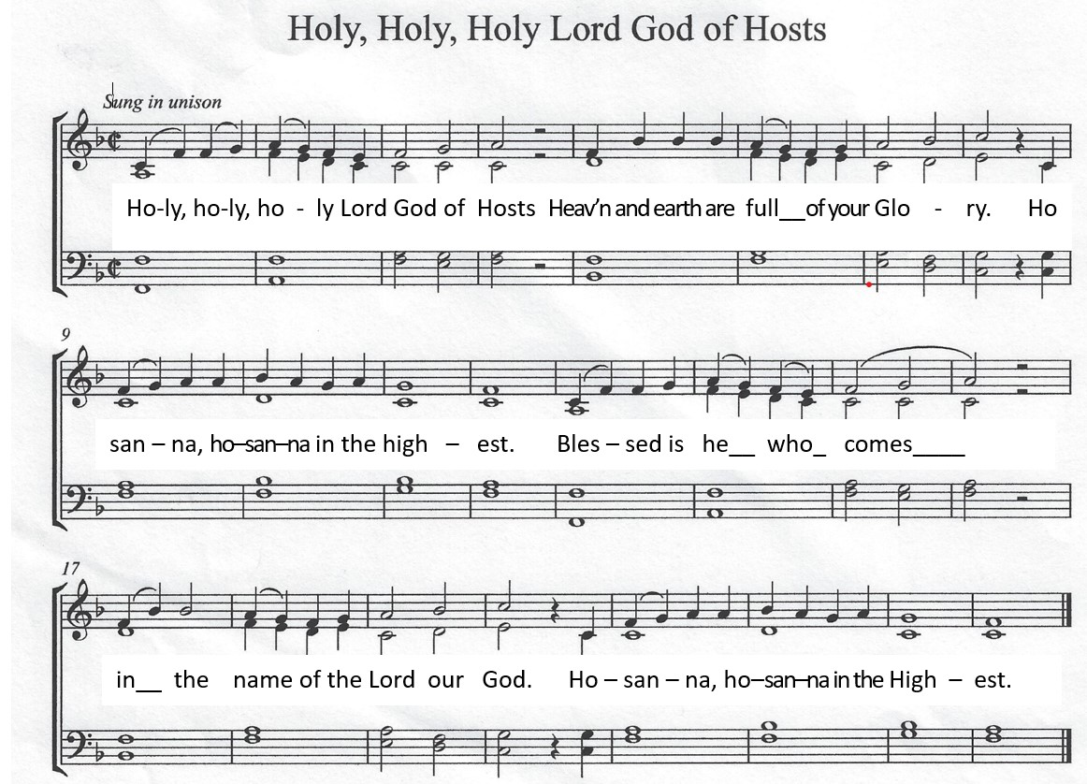
† SANCTUS

EUCHARISTIC MEDITATION
PRAYER OF CONSECRATION

WORDS OF INSTITUTION
Distribution of the Bread and Communion in the Body of Christ
Communion Song: “Behold the Lamb” v. 1-2 (printed on page 8)
Distribution of the Cup and Communion in the Blood of Christ
Communion Song: “Behold the Lamb” v. 3-4
PRAYER OF BLESSING
GOD COMMISSIONS US TO GO INTO THE WORLD
† HYMN OF PRAISE: “The Song of Simeon” (Tune: St. Columba, “How Sweet and Awesome Is the Place”)
Lord bid your servant go in peace, your word is now fulfilled.
These eyes have seen salvation’s dawn, this child so long foretold.
This is the Savior of the world, the Gentile’s promised light,
God’s glory dwelling in our midst, the Joy of Israel.
† BENEDICTION: Numbers 6:24-26
The LORD bless you and keep you;
The LORD make his face shine upon you and be gracious to you;
The LORD lift up His countenance upon you and give you peace.
† THREE-FOLD AMEN
† POSTLUDE



