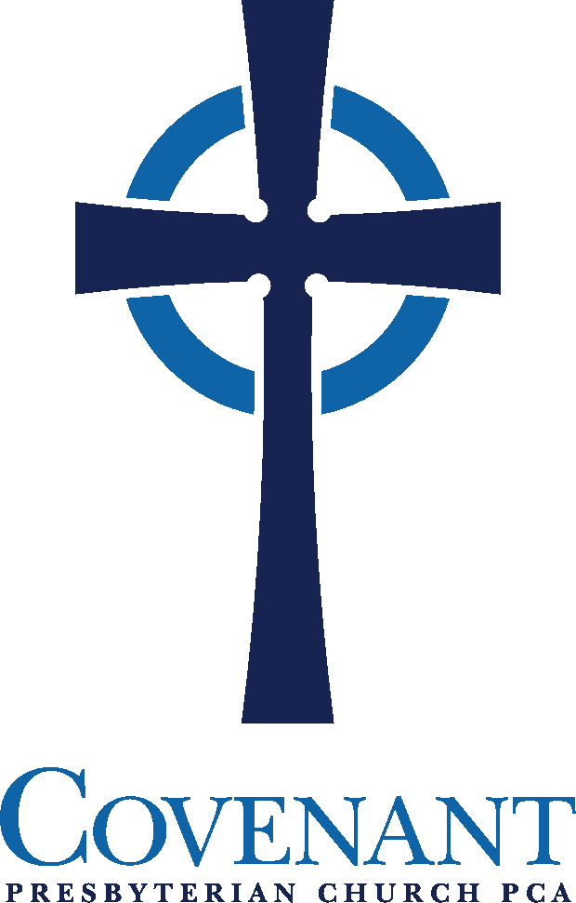

Jackson, Tennessee
February 2, 2025

ORDER FOR THE WORSHIP OF GOD
February 2, 2025
PREPARATION FOR WORSHIP
PRELUDE
ANNOUNCEMENTS
SCRIPTURE MEDITATION: John 10:27-30
“My sheep hear my voice, and I know them, and they follow me. I give them eternal life, and they will never perish, and no one will snatch them out of my hand. My Father, who has given them to me, is greater than all, and no one is able to snatch them out of the Father's hand. I and the Father are one.”
SILENT PRAYER
GOD CALLS US INTO HIS PRESENCE
† SALUTATION
In the name of the Father, and of the Son, and of the Holy Spirit.
Amen.
The Lord be with you! Ruth 2:4
And, also, with you!
This is the day the Lord has made;. Psalm 118:24
Let us rejoice and be glad in it!
† CALL TO WORSHIP: Hebrews 12:22-24
But you have come to Mount Zion and to the city of the living God, the heavenly Jerusalem, and to innumerable angels in festal gathering, and to the assembly of the firstborn who are enrolled in heaven, and to God, the judge of all, and to the spirits of the righteous made perfect, and to Jesus, the mediator of a new covenant, and to the sprinkled blood that speaks a better word than the blood of Abel.
†* HYMN OF PRAISE, NO. 34: “The God of Abraham Praise”

† PRAYER OF ADORATION

† Congregation stands, if able | * Seating for latecomers at this time | All Scripture readings are from the ESV® Bible (The Holy Bible, English Standard Version®). ESV® Text Edition: 2016. Copyright © 2001 by Crossway, a publishing ministry of Good News Publishers. Assistive listening devices are available for use during worship services. Please inquire at the sound booth.
GOD CLEANSES US OF OUR SINS

CALL TO CONFESSION:
Hear now the commandments of Your God, which he has commanded you to keep, saying, “You shall love the Lord your God with all your heart, with all your soul, with all your mind, and with all your strength.” This is the first and great commandment.
And the second, like unto it is this,
“You shall love your neighbor as yourself.”
Have you fully obeyed the Lord in all that he has commanded?
No, but we have sinned against Him in thought, word, and deed.
CORPORATE CONFESSION (congregation kneels as able)
Gracious God, our sins are too heavy to carry, too real to hide, and too deep to undo. Forgive what our lips tremble to name, what our hearts can no longer bear, and what has become for us a consuming fire of judgment.
Set us free from a past that we cannot change; open to us a future in which we can be changed; and grant us grace to grow more and more in your likeness and image; through Jesus Christ, the light of the world.
[Silent prayer of personal confession] Amen.

† ASSURANCE OF PARDON:
† THE PEACE
† GLORIA PATRI (with hands lifted)
Glory be to the Father, and to the Son,
And to the Holy Ghost;
As it was in the beginning,
Is now, and ever shall be,
World without end. Amen.
†* HYMN OF PRAISE, NO. 94: “How Firm a Foundation”

GOD CONSECRATES US BY HIS WORD
PRAYER FOR ILLUMINATION
OLD TESTAMENT READING: Psalm 61:1-4
This is the Word of the Lord
Thanks be to God!
EPISTLE READING: Hebrews 5:5-7
This is the Word of the Lord
Thanks be to God!
† PSALM 90, NO. 30: “Our God, Our Help in Ages Past”
† GOSPEL READING: Luke 22:39-46
This is the Gospel of Jesus Christ
Praise be to you, O Christ!
PREACHING OF GOD’S WORD
Higher Than I
† CONFESSION OF FAITH: Nicene Creed
We believe in one God, the Father Almighty
Maker of heaven and earth,
of all things visible and invisible.
And in one Lord Jesus Christ, the only-begotten Son of God,
begotten of His Father before all worlds,
God of God, Light of Light, very God of very God,
begotten, not made, being of one substance with the Father;
by whom all things were made;
who for us and for our salvation came down from heaven,
and was incarnate by the Holy Spirit of the virgin Mary,
and was made man;
and was crucified also for us under Pontius Pilate;
He suffered and was buried;
and the third day He rose again according to the Scriptures,
and ascended into heaven,
and is seated at the right hand of the Father;
and He shall come again, with glory,
to judge both the living and the dead;
whose kingdom shall have no end.
And we believe in the Holy Spirit, the Lord and giver of life,
who proceeds from the Father and the Son;
who with the Father and the Son together
is worshiped and glorified;
who spoke by the prophets;
and we believe in one holy catholic* and apostolic church;
we acknowledge one baptism for the remission of sins;
and we look for the resurrection of the dead,
and the life of the world to come. Amen. *catholic=universal
† PRAYER OF INTERCESSION AND LORD’S PRAYER
Our Father, Who art in heaven, Hallowed be Thy name.
Thy kingdom come. Thy will be done on earth as it is in heaven.
Give us this day our daily bread. And forgive us our debts,
As we forgive our debtors. And lead us not into temptation,
But deliver us from evil: For Thine is the Kingdom,
And the power, and the glory forever. Amen.
OFFERTORY
† DOXOLOGY (with hands lifted)
Praise God from whom all blessings flow;
Praise Him all creatures here below;
Praise Him above, ye heavenly host;
Praise Father, Son, and Holy Ghost. Amen
† PRAYER OF THANKSGIVING
GOD COMMUNES WITH US AT HIS TABLE
† SURSUM CORDA
Lift up your hearts.
We lift them up to the Lord.
Let us give thanks to the Lord our God.
It is right to give our thanks and praise.
It is right, and good, and a joyful thing, that we should at all times and in all places give thanks to You, holy Lord, almighty Father, everlasting God, through Jesus Christ our Lord. Therefore with angels and arch angels and with all the company of heaven we praise and magnify Your glorious name, evermore praising you and singing …
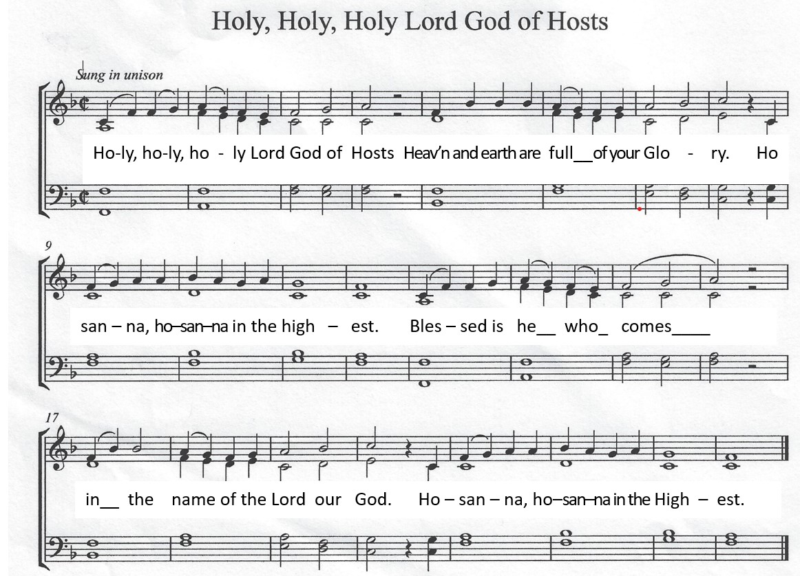
† SANCTUS

EUCHARISTIC MEDITATION
PRAYER OF CONSECRATION

EUCHARISTIC MEDITATION
PRAYER OF CONSECRATION
WORDS OF INSTITUTION
Distribution of the Bread and Communion in the Body of Christ
Communion Song No. 500: “Rock of Ages, Cleft for Me” v. 1-2 (lyrics, page 8)
Distribution of the Cup and Communion in the Blood of Christ
Communion Song No. 500: “Rock of Ages, Cleft for Me” v. 3-4
PRAYER OF BLESSING
GOD COMMISSIONS US TO GO INTO THE WORLD
† HYMN OF PRAISE, NO. 642: “Be Thou My Vision”
† BENEDICTION: Numbers 6:24-26
The LORD bless you and keep you;
The LORD make his face shine upon you and be gracious to you;
The LORD lift up His countenance upon you and give you peace.
† THREE-FOLD AMEN
† POSTLUDE

Rock Of Ages

Verse 1
Rock of Ages cleft for me
Let me hide myself in thee
Let the water and the blood
From thy wounded side which flowed
Be of sin the double cure
Save from wrath and make me pure

Verse 2
Not the labors of my hands
Can fulfill thy law's demands
Could my zeal no respite know
Could my tears forever flow
All for sin could not atone
Thou must save and thou alone

Verse 3
Nothing in my hand I bring
Simply to the cross I cling
Naked come to thee for dress
Helpless look to thee for grace
Foul I to the fountain fly
Wash me Savior or I die

Verse 4
While I draw this fleeting breath
When mine eyes shall close in death
When I soar to worlds unknown
See thee on thy judgment throne
Rock of Ages cleft for me
Let me hide myself in thee

Augustus Montague Toplady, Thomas Hastings
CCLI Song #40588
© Words: Public Domain; Music: Public Domain
For use solely with the SongSelect® Terms of Use. All rights reserved. www.ccli.com
CCLI License #11313639


